

**Ghana**

**Justice for Children**

**Operational Plan**

(J4COP)

19 May 2017

# EXECUTIVE SUMMARY

This is the Operational Plan (OP) to roll out or implement the Justice for Children Policy (J4CP). The J4CP contains various objectives and strategies towards justice reforms for improved benefits to children. This is an Operational Plan to cover the period 1July 2017 to 31 December 2021, to be monitored and updated on a quarterly basis by the Department of Children (DOC) under the Ministry of Gender Children and Social Protection, with the support of the various Child Protection Committees (CPCs) at different levels. The J4CP is complimentary to the Child and Family Welfare Policy (CFWP), which is aimed at ensuring that children are well cared for at the community level and prevented from falling foul of the law.

The National Child Protection Committee (NCPC), with support from one of its two subcommittees, the Justice for Children Coordinating Committee (J4CCC), will oversee the implementation of this Operational Plan (OP). The NCPC will have overall accountability for the successful execution of this Operational Plan. The secretariat of the NCPC and its Sub Committees is located at the DOC that is also responsible for monitoring and evaluation of the J4CP.

The seven objectives of the J4CP are as follows.

1. Prevent juvenile offending:
2. Promote formal and community justice systems
3. Strengthen programmes for rehabilitation, social reintegration and resettlement
4. Protect children as witnesses and victims of crimes
5. Promote access to justice for children involved in family and other civil proceedings
6. Guide the reform of laws, policies and procedures
7. Ensure the provision of financial and human resources

Each objective will be achieved through one or more strategies by means of strategic initiatives. These initiatives (programmes, projects and activities), as described in the scorecards in this Operational Plan require resources – human, physical, structural and financial resources. The total J4COP budget for the 5-year period is **GH¢ 84.38 million** with GH¢ 4.5 million required for the 6-month period in 2017 and an average of GH¢ 20 million per year for subsequent years.

**Contents**

EXECUTIVE SUMMARY i

1. BACKGROUND & RATIONALE 1

2. POLICY OBJECTIVES AND STRATEGIES 4

3. JUSTICE FOR CHILDREN SCORECARD 5

4. J4C COSTING & BUDGETING 37

ANNEXURE A: J4C STAKEHOLDERS 39

ANNEXURE B: J4C PROCESSES 40

ANNEXURE C: IMPLEMENTATION GUIDELINES 43

**Acronyms & Abbreviations**

Acc Accountable Institution (for objective)

ADR Alternative Dispute Resolution

BDR Birth and Death Registry

BL Baseline

CB Capacity Building

CBO Community Based Organisation

CCPC Community Child Protection Committee

CFWP Child and Family Welfare Policy

CPC Child Protection Committee

CHRAJ Commission for Human Rights and Administrative Justice

CJS Community Justice System

CMP Communication Management Plan

CSO Civil Society Organisation

CSU Child Support Unit

DCPC District Child Protection Committee

DOC Department of Children

DP Development Partner

DCD Department of Community Development (under MMDAs)

DOVVSU Domestic Violence and Victim Support Unit

DSW Department of Social Welfare (under MOGCSP)

FBO Faith-Based Organisation

FJS Formal Justice System

GBA Ghana Bar Association

GBV Gender Based Violence

GES Ghana Education Service

GES Ghana Education Service

GHS Ghana Health Service

GIS Ghana Immigration Service

GJA Ghana Journalist Association

GLC General Legal Council

GPC Ghana Psychology Council

GPS Ghana Police Service

GPrS Ghana Prison Service

GRB Ghana Refugee Board

HR Human Resources

ILGS Institute of Local Government Studies

J4CCC Justice for Children Coordinating Committee

J4COP Justice for Children Operational Plan

J4CP Justice for Children Policy

JS Judicial Service

JCC Junior Correctional Centre

LAS Legal Aid Scheme

LEAP Livelihood Empowerment Against Poverty

LGS Local Government Service

MDAs Ministries, Departments and Agencies

MERIL Measure, Evaluate, Report, Improve, Learn

MMDAs Metropolitan, Municipal and District Assemblies

MOC Ministry of Communication

MOCRA Ministry of Chieftaincy and Religious Affairs

MOE Ministry of Education

MOF Ministry of Finance

MOGCSP Ministry of Gender, Children and Social Protection

MOLGRD Ministry of Local Government and Rural Development

MOH Ministry of Health

MOI Ministry of Interior

MOJAGD Ministry of Justice & Attorney-General Department

NA Not Applicable or Not Available

NCPC National Child Protection Committee

NGO Non-Governmental Organisation

NHC National House of Chiefs

NHIS National Health Insurance Scheme

NMC National Media Commission

OP Operational Plan

PI Performance Indicator

PM Project Management

PO Probation Officer

PPME Policy Planning, Monitoring & Evaluation (in MDAs)

Q Quarterly

R Rating

RCPC Regional Child Protection Committee

Resp Responsible Institution (for initiative)

RSIM Research Statistics and Information Management

SCC Senior Correctional Centre

SDO Social Development Officer

SER Social Enquiry Report

SJO Self/Jointly/Outsource

SOP Standard Operating Procedure

Supp Supporting Institution(s) or stakeholders

SWO Social Welfare Officer

TA Traditional Authority

UNICEF United Nations Children's Fund

# BACKGROUND & RATIONALE

## Background

The Government of Ghana, with support from UNICEF, is working to strengthen the country’s **Child Protection System** to make it more effective in preventing violence, abuse and exploitation and in responding to maltreatment of children when needed. A strengthened child protection system will also ensure justice for all children. Through supporting the strengthening of the child protection system in Ghana, UNICEF will help ensure that Ghana’s children increasingly grow up in homes and communities that are free from violence, abuse and exploitation. An effective child protection system requires a **strong policy framework**.

Ghana has created a **new National Child Protection Policy Framework** that is culturally appropriate and based on a joint partnership between the formal justice system and the community justice system in protecting children. There are two new policies that ensures this which are the Child and Family Welfare Policy (CFWP) which is aimed at ensuring that children are well cared for at the community level that will prevent them from falling foul of the law and the Justice for Children Policy, which ensures that if they fall into the cracks or are in contact with the law they are treated well. An operational plan has already been prepared for the CFWP.

This Operational Plan is designed to operationalise the Justice for Children Policy.

## Related Policies

This J4CP adds to existing policies that seek to protect the rights of children in Ghana. Among other policies, the following other recently launched key policies are:

1. National Social Protection Policy
2. National Gender Policy
3. School Feeding Policy
4. Child and Family Welfare Policy (CFWP)

Brief summaries of these other policies are provided below:

1. The **National Social Protection Policy** provides a framework for a coherent social protection system. The policy provides mechanisms to protect persons living in situations of extreme poverty and related vulnerability and exclusion. It creates an all-inclusive and socially empowered society. It supports the principle that every Ghanaian matters and is capable of contributing to national development. Through this policy, the inequality gap will be closed for the total inclusion of all Ghanaians.
2. The goal of the new **School Feeding Policy** is to have a well-organized, decentralized intervention system to provide disadvantaged school children with nutritionally adequate, locally produced food and thereby reduce poverty through improved household incomes and effective local economic development. The policy objectives include providing sustainable social development support to children in deprived Ghanaian communities; strengthening collaboration and coordination between national and sub-national actors; fostering local economic development in food production, marketing and processing; and promoting local collaboration and joint ownership of child nutrition, health promotion and education by local authorities, communities and stakeholders. It provides cross-cutting interventions related to gender-sensitivity and social inclusivity, social accountability, environmental management and sustainability and image building and information management for school feeding.
3. The **National Gender Policy** aims at mainstreaming gender, women‘s empowerment and social protection concerns into national development processes for equitable livelihood for women and men, boys and girls. The policy dwells on provisions in International Instruments ratified by Ghana, the Millennium Development Goals (MDGs) and Ghana‘s National Development Frameworks including the Ghana Shared Growth and Development Agenda I (2010 – 2013) and II (2014 – 2017). It provides broad objectives and policy commitments, as well as a detailed institutional framework for the operationalization of government‘s commitments to achieve gender equality and women‘s empowerment in its national vision of investing in people for better social and economic growth. The broad policy objectives are: Women Empowerment and Livelihoods, Women Rights and Access to Justice, Women Leadership and Accountable Governance, Economic Opportunities for women and Gender Roles and Relations.

1. The **Child and Family Welfare Policy** seeks to establish a well-structured and well-coordinated Child and Family Welfare system that promotes the well-being of children from harm. The overall goal of the policy is to help formulate child and family welfare activities to more effectively prevent and protect children from all forms of violence, abuse, neglect and exploitation. The objectives include to ensure effective coordination of the child and family systems at all levels, to empower children and families to better understand abusive situations and make choices to prevent and respond to situations of risk, to build capacity of institutions and service providers to ensure quality of services for children and families in urban and rural areas, to reform existing laws and policies to conform to the child and Family welfare system and ensure the provision of adequate human, technical and financial resources required for the functioning of the Child and Family Welfare system at all levels.

## Justice for Children Policy Summary

This section summarises the policy statement from the Justice for Children Policy (J4CP). The overall goal of this Policy is to improve access to justice for children in line with acceptable standards, values and beliefs of the formal and community justice systems.

The J4CP was launched on 27 September 2016. Under the Policy all children will be given equal justice through both formal and the community justice systems.

The **Justice for Children Policy** addresses both criminal and civil cases involving children and seeks to establish a well-structured and coordinated Justice for Children system that promotes the wellbeing of children, prevents violence, exploitation and abuse.

The overall goal of this Policy is to improve access to justice for children in line with acceptable standards, values and beliefs of the formal and community justice system. It aims to promote greater cooperation between the formal and the community justice systems to work together as a cohesive national system that ensures access to justice for all children. The policy has also been designed to maximise and utilise existing resources and capacities with a clear intent of identifying viable and sustainable solutions for an effective justice for children system

It is concerned with all children who would come in contact with the justice system –

1. Victims (V);
2. Witnesses (W);
3. Alleged offenders (O*); and
4. Offenders (O)

It also covers all other cases involving children.

The Policy is to provide for an improvement in the handling of justice for children cases by the formal justice system and community justice system. It seeks to link up both systems in the interest of children for a coherent Justice system for children fit for Ghana.

## Stakeholders

The Justice for Children Policy (J4CP) indicates that the policy covers all criminal and civil suits involving children. It is focused on all children in contact with the justice system.

The Justice for Children System as described in the policy document consists of both formal and community components. Key stakeholders in the **Formal Justice System** (FJS) include the following:

* Ministry of Gender Children and Social Protection (MOGCSP) - Department of Social Welfare (DSW) and Department of Children (DOC),
* Ministry of Interior (MOI) – Ghana Police Service, Ghana Prison Service, Ghana Refugee Board and Ghana Immigration Service
* Judicial Service (JS) - Courts
* Ministry of Local Government and Rural Development (MOLGRD) – Metropolitan Municipal and District Assemblies (MMDAs)and Births and Deaths Registry (BDR)
* Ministry of Justice and Attorney Generals Department (MOJAGD) and the Legal Aid Scheme
* Ministry of Education (MOE) including the Ghana Education Service (GES) and the Guidance and Counselling Division
* Ministry of Health (MOH) including the Ghana Health Service (GHS)
* Ministry of Chieftaincy and Religious Affairs (MOCRA)
* Ministry of Finance
* Parliament
* Commission on Human Rights and Administrative Justice (CHRAJ)

Key stakeholders in **Community Justice System** (CJS) include:

* National House of Chiefs
* Traditional Authorities
* Religious Leaders
* Civil Society Organisations (CSOs), including NGOs, FBOs and CBOs
* Family Heads
* Families

Other stakeholders, supporting both the FJS and CJS are Development partners - including UNICEF

Refer to ***Annexure A*** for a depiction of these stakeholders in relation to one another on national, regional, district and community levels. The Child Protection Committees (CPCs) are also indicated.

## Justice for Children Processes

In this Operational Plan, the Justice for Children processes will be clearly mapped and described, supported by the development of manuals where required to enable all stakeholders to clearly understand and follow the required processes in support of the policy principles and objectives.

***Annexure B*** offers an overview of the Community Justice System operating within the broader Formal Justice System. The civil and criminal processes, through the CJS and FJS are broadly described and depicted. Note that initiatives in this J4COP address the need for the development of Standard Operating Procedures (SOPs), supported by manuals to detail these processes.

# POLICY OBJECTIVES AND STRATEGIES

Seven objectives have been identified in the J4CP. These policy objectives with their respective strategies are as follows:

**Objective 1: Prevent juvenile offending**

* Strategy 1.1: Strengthen families and develop interventions to prevent juvenile offending.

**Objective 2: Promote formal and community justice systems to enhance access to justice for children in conflict with the law**

Formal Justice System:

* Strategy 2.1: Strengthen the formal justice system and make it more child-friendly during arrest, investigation, pre-trial, trial, and committal;
* Strategy 2.2: Ensure legal assistance for children;
* Strategy 2.3: Ensure greater efficiency in the process of prosecution and trial;

Community Justice System:

* Strategy 2.4: Reform the Child Panels;
* Strategy 2.5: Promote the use of community justice mechanisms and diversion at the community level;
* Strategy 2.6: Establish an effective response and referral system between the community justice for children system and the formal system.

**Objective 3: Strengthen programmes for rehabilitation, social reintegration and resettlement**

* Strategy 3.1: Strengthen social reintegration and resettlement of children to address juvenile delinquency and social needs of the juvenile;
* Strategy 3.2: Increase the number of probation officers and enhance the professionalism of the justice for children delivery system.

**Objective 4: Protect children as witnesses and victims of crimes**

* Strategy 4.1: Encourage family and community involvement;
* Strategy 4.2: Provide victim/witness support services;
* Strategy 4.3: Ensure the protection of the child’s dignity, safety and privacy in the entire trial process (protection of safety and privacy);
* Strategy 4.4: Provide compensation to child victims;
* Strategy 4.5: Provide free services for child victims (e.g. medical, counselling, legal etc.).

**Objective 5: Promote access to justice for children involved in family and other civil proceedings**

* Strategy 5.1: Support community justice systems in dealing with civil cases;
* Strategy 5.2: Adopt a new approach for dealing with child maintenance cases;
* Strategy 5.3: Ensure legal and other representation for children;
* Strategy 5.4: Reform of Family Court and enforcement of orders.

**Objective 6: Guide the reform of laws, policies and procedures to improve access to justice for children**

* Strategy 6.1: Promote legal and policy reform.

**Objective 7: Ensure the provision of financial and human resources for implementation of the policy**

* Strategy 7.1: Undertake analysis of and advocacy for adequate financial, technical and human resources required for an effective justice for children system

# JUSTICE FOR CHILDREN SCORECARD

This section contains the detailed J4COP scorecard (based on the Balanced Scorecard) – a matrix detailing the strategies for each objective, together with their related initiatives. The left-hand side of the scorecard contains the objective details (what to achieve in each strategy, in terms of performance indicators and targets) with the right-hand side presenting the initiatives required to achieve these targets.

The scorecard terms are defined as follows:

* **Performance indicators (PIs)**: Performance indicators (PIs) refer to objectives and not initiatives. Each objective strategy generally has one or two PIs to help making it SMART (Specific, Measurable, Agreed-to/Aligned, Realistic & Time-bound). These PIs can be quantitative or qualitative. Quantitative PIs are e.g. the number of people trained, the number of courts with child-friendly SOPs or the amount of funds received. The unit of measurement for these can be numbers, GH¢ amount or even a percentage. An example of a qualitative PI is stakeholder satisfaction as measured through surveys. These are normally measured in terms of percentages or scores based on different criteria. Where inputs and processes are often quantitative, outputs and outcomes tend to be more of a qualitative nature. The BSC recommends to include both leading and lagging PIs. Leading PIs indicate inputs and processes (e.g. the number of people trained) and lagging PIs the outputs and outcomes (e.g. improved performance resulting from this training). In performance measurement, organisations need to clearly identify the objectives and then the path required to get there, then carefully design meaningful PIs to assess performance of the whole Input-Process-Output-Outcome value creation chain.
* **Targets**: Targets are for objectives and not initiatives. For each PI, the baseline (BL) is provided (taken as the 1st Quarter of 2017), together with the annual targets, viz. Dec 2017, Dec 2018, Dec 2019, Dec 2020 and Dec 2021. Where BLs or targets are not available or not applicable, they are indicated by “NA”. Where BLs or targets need to be determined, a “TBD” is shown. Most of the BLs and targets included in this OP have not been scientifically determined. These will have to be improved during quarterly performance reviews, involving Measure, Evaluate, Report, Improve & Learn. The sources of the determined BLs and targets should be indicated in the PI columns.
* **Accountabilities (Acc)**: The term ‘accountability’ is used for objectives and ‘responsibilities’ for initiatives. The accountable institution takes ownership of the objective and is held accountable for achieving the stated annual targets per PI. Accountability is assigned to the institution whose mandate best aligns with the specific objective. The accountable institution therefore has to act as programme manager (with the support from DOC) to ensure that all related initiatives work together to achieve the required performance targets. Many of these related initiatives may have responsibilities with budgets from other institutions.
* **Initiatives**: Objectives are achieved through different strategic approaches by means of initiatives. Initiatives include current and future programmes, projects and activities, requiring resources, such as financial, human, structural and physical resources. While a project is a group of activities managed in a coordinated way, a programme is a group of related projects managed in a coordinated way for improved efficiencies to achieve a specific objective. Both projects and programmes are unique and temporary in nature and need to be managed by the Project Management “toolbox” (with its methodologies, tools and techniques). Activities, in contrast, are ongoing operations to be managed by the Operational Management “toolbox”. Activities/operations are not unique or temporary, but ongoing repetitive activities. Note that where formal detailed project or programme plans are required for initiatives, it is indicated with: ***\*\*detailed project plan**.*** The progress of projects/programmes are measured based on these project/programme plans – mostly in terms of scope, time, cost and quality.
* **Current Progress (CP%)**: This column shows the progress of the initiative during the quarter under review. Where initiatives have not started, a 0% is shown. These percentages will be updated during quarterly performance management, based on documented proof.
* **Responsibilities (Resp)**: This is the institution responsible to successfully plan and execute the initiative. The responsible institution plays the role of project manager for this initiative, but also has to liaise with other project managers on related projects. The responsible institution should preferably provide the budget/funds and other resources for the initiative.
* **Support (Supp)**: As with most projects/programmes, various team members are required to carry out the various project activities, in support of the project manager. In this column, the stakeholders are listed who will play a significant support role to successfully complete the initiative on time and within budget, according to the scope and quality requirements.
* **Self/Jointly/Outsource (SJO)**: This indicates whether the initiative will be done by Self, Jointly or Outsourced. “Self” is the responsible institution; “Jointly” when the responsible and support stakeholders fairly evenly share the workload; “Outsource” when consultants/ contractors/ suppliers will be used (which will lead to higher costs).

The scorecard will be used as the basis for quarterly performance reviews. The two key components to be measured, evaluated and reported are:

1. Objective (left): To what extent we are achieving our objectives (per strategy) by measuring performance for each PI; and
2. Initiative (right): To what extent we are completing our initiatives according to scope, time, cost and quality requirements.

|  |  |
| --- | --- |
| ***OBJECTIVE 1:***  ***STRATEGY 1.1:*** | **PREVENT JUVENILE OFFENDING**  *As the prevention work centered on functional families is governed by the* ***CFWP*** *and done through regular dialogue amongst social workers/community workers, children, families and communities, this objective specifically launch initiatives to further prevent children from offending and related damages associated with it.*  **Strengthen families and develop interventions to prevent juvenile offending.**  *Justice sector related pro-active, preventative measures will be emphasised and grounded in strengthening families; the school system will play an important role in identifying at-risk children and in a collaborative way address children’s needs.*  *[It is required to do cross referencing with the CFWOP initiatives aimed at prevention, especially the activities relating to sensitisation]* |
| ***ACCOUNTABLE:*** | **MOGCSP** |

|  |  |  |  |  |  |  |  |  |  |  |  |  |
| --- | --- | --- | --- | --- | --- | --- | --- | --- | --- | --- | --- | --- |
| ***PI*** | ***Target*** | ***Initiatives*** | ***CP***  ***%*** | ***Resp*** | ***Supp*** | ***SJO*** | ***Cost***  ***GH¢000*** | ***17*** | ***18*** | ***19*** | ***20*** | ***21*** |
| **A.** Annual no, of juvenile cases reported to and handled by the CJS including CHRAJ    **B.** No of interventions addressing at-risk/vulnerable school children | BL= 200  17= 180  18= TBD  19= TBD  20= TBD  21= TBD  BL= 0  17= 2  18= 4  19= 6  20= 8  21=10 | 1. **Empower parents, guardians and families with rights based information and knowledge about available processes to address abuse** to enable themto identify abused children leading to triggering of the CJS and to be more involved in the FJS when children are in conflict with the law | 0 | DSW | MMDAs (DSW/DCD), CSOs | J | 300 | X | X | X | X | X |
| 1. **Empower vulnerable children** to better cope with situations to prevent juvenile offending and victimisation | 0 | DSW | MMDAs (DSW/DCD), CSOs | J | 100 | X | X | X | X | X |
| 1. **Equip and empower schools** to identify vulnerable children or those at risk and to link them with the formal justice system for required interventions to prevent them from being abused and from the children becoming offenders | 0 | MOE | GES, DSW CSOs | J/O | 500 |  | X | X | X | X |
| 1. **Strengthen and equip justice sector institutions** tointeract more with the CJS and to develop and supervise more diversion programmes under the FJS through call centres/CPCs/etc.; address e.g. gaming centres, bars, internet cafes; make helplines available; MMDAs to enforce by-laws  **\*\*Detailed Project Plan\*\*** | 0 | DSW | MDAs (DSW/DCD), GPS, JS, CHRAJ, CSOs | J | 500 | X | X | X | X | X |

|  |  |
| --- | --- |
| ***OBJECTIVE 2 (FJS):***  ***STRATEGY 2.1:*** | **PROMOTE THE FORMAL JUSTICE SYSTEM TO ENHANCE ACCESS TO J4C IN CONFLICT WITH THE LAW**  *Whilst children should be held accountable for their actions, special measures are needed at all stages of the process to ensure that children are treated in a sensitive and respectful manner, with due regard for their age and legal status as a child; ensure children in conflict with the law are treated according to the Guiding Principles (caring, protective, sensitive, non-discrimination, best interest and fairly, right to be heard, representation, fair trial, legal protection & social support)*  **A. Strengthen the FJS and make it more child-friendly during arrest, investigation, pre-trial, trial and committal**  *Capacity will be enhanced in all key J4C institutions by addressing* ***S****OPs,* ***S****paces,* ***S****ystems,* ***S****tructures &* ***S****kills. These institutions include Ghana Police Service, Department of Social Welfare, Commission for Human Rights and Administrative Justice, Legal Aid Board, Ghana Immigration Service, Ghana Refugee Board, Remand Homes, Courts and Correctional Centres.* |
| ***ACCOUNTABLE:*** | **MOGCSP** |

|  |  |  |  |  |  |  |  |  |  |  |  |  |
| --- | --- | --- | --- | --- | --- | --- | --- | --- | --- | --- | --- | --- |
| ***PI*** | ***Target*** | ***Initiatives*** | ***CP***  ***%*** | ***Resp*** | ***Supp*** | ***SJO*** | ***Cost***  ***GH¢000*** | ***17*** | ***18*** | ***19*** | ***20*** | ***21*** |
| **A.** % of J4C Institutions with child friendly services in terms of **S**OPs, **S**paces, **S**ystems & **S**kills criteria - by means of annual audits  **B.** **S**kills: No of personnel in FJS trained in child friendly approaches | BL= TBD  17= 20  18= 30  19= 35  20= 40  21= 45  BL= 2,300  17= 2,800  18= 3,400  19= 4,000  20= 4,600  21= 5,200 | 1. **Do a status quo assessment** of current **S**OPs, **S**paces, **S**taff & **S**kills and **S**ystems at all the J4C Institutions at the NCPC level; **determine gaps** based on minimum standards and designs; **develop a programme plan** (with detailed scope of what exactly to be done at each institution in terms of SOPs, Spaces, Systems, Structures, Staff and Skills – with detailed costs and schedules for improvements to close the gaps in each institution over the following 5 years) at police stations, courts, and other J4C institutions ***\*\*detailed project plan\*\**** | 0 | MOGCSP/  NCPC | GPSG DSW, GPrS, JS, CHRAJ | O | 500 | X | X |  |  |  |
| 1. **Develop/Update child friendly SOPs* for all justice sector agencies** (incl. interactions with other stakeholders):    1. **Police**: Update Child Friendly SOPs and develop colour coding of dockets to give priority to cases involving child victims and witnesses    2. **MOJAGD & Courts**: Develop child friendly SOPs incl. considering e.g. colour coding of dockets to give priority to cases involving child victims and witnesses    3. **DSW:** Update the child friendly SOPs for DSW national and regional (intra only) and develop at district level child friendly SOPs for DSW working at the MMDA level; update the probation manual for child friendly procedures and systems at the DSW; develop SOPs for JCC & Junior Remand Homes    4. **CHRAJ:** Update CHRAJ’s case handling manual to include child friendly procedures and systems    5. **LAS:** Update child friendly SOPs for legal aid lawyers    6. **SCC:** Develop child friendly SOPs for staff    7. **GRB:** Develop child friendly SOPs for staff    8. **GIS:** Develop child friendly SOPs for staff | 50  0  0  0  0  0  0  0 | GPS  JS/ MOJAGD  DSW  CHRAJ  LAS  GPrS  MOI  MOI | MOI, MOGCSP, DSW, CHRAJ, LAS, MOJAGD, JS, GNCRC, DPs,  GRB, GIS | J/O  J/O  J/O  J/O  J/O  J  J  J | 100  300  100  50  50  50  50  50 |  | X  X  X  X  X  X  X  X |  |  |  |
| 1. **Integrate all SOPs** and develop **summaries of training manuals** for more child-friendly SOPs, Staff, Spaces and Systems during arrest, investigation, pre-trial, trial and committal; strengthened inter agency collaboration for effective and timely delivery of J4C services | 0 | MOGCSP | JS, MOI, DSW, CHRAJ, LAS, MOJAGD, JS, GNCRC, DP, MOC, GPS | J/O | 100 |  | X |  |  |  |
| 1. **Print & disseminate manuals**, pocket guides/summaries – support relevant institutions to post SOPs and manuals on their respective websites with links to the website of the MOGCSP | 0 | MOGCSP | ALL | O | 1000 |  | X | X |  |  |
| 1. **Monitor compliance with manuals/SOPs**:monitoring to ensure strict compliance to SOPs at police stations and courts to promote fair trials for children - institutions and individuals working in the system should apply child-friendly methods in the execution of their duties | 0 | DSW | GPS, JS, CPCs at all levels, DOC, MOGCSP | J | 400 |  | X | X | X | X |
|  |  |  |  |  |  |  |  |  |  |  |
| 1. **Skills:** Provide specialised training for FJS actors according to plan – to make services child friendly at Police, DSW, CHRAJ, LAS, GIS, GRB, Remand Homes, Courts (incl. Family Court magistrates) and Correctional Centres; content incl. the J4CP, J4COP and the application of the new **S**OPs, **S**paces & **S**ystems | 0 | DOC | JS, MOI, MOGCSP, DSW, GIS, MMDAs, CHRAJ, LAS, MOJAGD, GNCRC, DPs | J/O | 3000 |  |  | X | X | X |
| 1. **Skills:** Integrate J4C issues in **law school curricula;** to be mandatory; create specialisation in J4C;make continuing J4C education for lawyers a requirement for yearly licenses; lobby to review the law | 0 | GLC | GBA, MOJ, MOJAGD, MOGCSP, JS | J | 100 |  | X | X | X | X |
|  |  |  |  |  |  |  |  |  |  |  |
| 1. **Provide child-friendly Spaces** at all justice sector agencies** according to the detailed programme plan:    1. **Police Stations**: plan, design and establish Child Protection Desks (combined with an AG’s child support desk) in all police stations (e.g. containers), managed by trained staff – say average 5 stations per District in 20 pilot districts – based on standard designs    2. **Courts**: Provide child-friendly spaces at courts according to plan; spaces to facilitate children’s testimonies; re-arrange the physical layout of the courtroom; arrange a separate waiting area for children and their parents; refurbish judge’s chambers (50 Chambers at the District Level).    3. **LAS**: Provide child-friendly spaces at the LAS;    4. **CHRAJ**: Improve/rearrange child-friendly spaces    5. **GIS & GRB**: Provide child-friendly spaces at GIS & GRB – on national level; plan for child friendly spaces for future refugee camps    6. **SCCs:** Refurbish child-friendly spaces at SCC    7. **DSW**: Provide and refurbish child-friendly spaces at JCCs and Junior Remand Homes for children (according to plan) in southern and northern sectors of Ghana | 0  0  0  0  0  0  0 | GPS  JS  LAS  CHRAJ  GIS & GRB  GPrS  DSW | MMDAs, MOJAGD, MOGCSP, MOF, MOI, AESL,  DPs | J  J  J  J  J  J  J | 10000  4000  1500  500  500  500  500 |  | X  X  X  X  X  X  X | X  X  X  X  X  X  X | X  X  X  X  X  X  X | X  X  X  X  X  X  X |
| 1. **Systems: Ensure that all relevant institutions capture data** on child related cases and **analyse** periodically; keep corresponding **data and record keeping** in easily retrievable formats (DSW, Police, AGs, Courts) | 0 | MOGCSP | JS, MOI, DSW, CHRAJ, LAS, MOJAGD, MOJ, GNCRC, DP, MOC, GSS | J | 600 |  | X | X | X | X |

Notes:

* All **SOPs** will be supported by training manuals. SOPswill include (refer to the J4CP for more details): family tracing, accurate determination of ages; mechanisms and standards to ensure children’s dignity, safety and privacy; giving priority to cases involving child Offenders/Victims/Witnesses; reducing unnecessary delays by proactively managing the number and duration of adjournments; using colour-coded dockets so that cases involving children can be easily identified and prioritised by sensitized investigators, prosecutors and the court system; facilitating children’s testimonies by the of use alternatives to *viva voce* testimony, such as video recorded testimony; using an appropriate notification system so children only attend court when necessary; ensuring that the child is accompanied by a Victim/Witness supporter; allowing children to testify from behind a screen or through closed circuit television; closing the courtroom to the public when the child is testifying; allowing for frequent recesses, taking into account the child’s age and attention span; children questioned in language appropriate to their age and level of understanding; the nature of questioning strictly controlled by the judge; not permitting perpetrators to cross-examine a child directly; undertake physical and forensic medical examinations where necessary in the best interests of the child, in a child-sensitive manner; referring all child victim cases reported to the police to the SW&CD Department for appropriate follow-up; arranging appropriate temporary safe shelter; more child-friendly mechanisms to approach CHRAJ directly for advice or to file a complaint; appointing a *guardian ad litem* to represent the interests of the child in any family, estate or other civil proceedings where the interests of the child conflict with that of a parent or other adult party

**\*\* Spaces** at the above venues include separated places for hearing children’s cases and the holding of accountability/family group conferences / victim offender mediation.

|  |  |
| --- | --- |
| ***STRATEGY 2.2:*** | **Ensure legal assistance for children**  *Give children special priority with respect to access to legal aid and support through the court process* |
| ***ACCOUNTABLE:*** | **MOGCSP** |

|  |  |  |  |  |  |  |  |  |  |  |  |  |
| --- | --- | --- | --- | --- | --- | --- | --- | --- | --- | --- | --- | --- |
| ***PI*** | ***Target*** | ***Initiatives*** | ***CP***  ***%*** | ***Resp*** | ***Supp*** | ***SJO*** | ***Cost***  ***GH¢000*** | ***17*** | ***18*** | ***19*** | ***20*** | ***21*** |
| **A.** Annual no of children receiving legal assistance | BL= 90  17= 200  18= 200  19= 200  20= 200  21= 200 | 1. **Improve the Legal Aid Scheme System** to expand children’s access to legal aid by upscaling the training of officers on child friendly services, setting up of children’s desks and color coding of children’s files; | 30 | LAS | MOJAGD, MOF, AESL | J | 450 | X | X | X | X | X |
| 1. **Develop and maintain a directory of lawyers** with J4C specialisation who are willing to provide free or highly subsidised legal advice/services. | 0 | LAS | MOJAGD, JS, GPS, GBA | J | 50 | X | X | X | X | X |
| 1. **Train and attach a legal aid official to each Police Station/Juvenile Court** (in future Family Court) | 0 | LAS | MOJAGD, JS, GPS | J | 150 | X | X | X | X | X |
| 1. **Train and institute a certification system for paralegals trained by relevant institutions**; based on developed curriculum; then deploy them to assist the Police and with the out of court settlement of cases and the handling of court cases ***\*\*Detailed Project Plan\*\**** (incl. short term & long term plan) | 0 | GLC | DOC, MOJAGD, LAS, GBA, Ghana School of Law | J | 2000 | X | X | X | X | X |

|  |  |
| --- | --- |
| ***STRATEGY 2.3:*** | **Ensure greater process efficiencies in prosecution and trial**  *Establish Family Courts; track and schedule children’s cases separately to give priority; consider ADR at first appearance; POs prepare SERs; family conferences will be convened* |
| ***ACCOUNTABLE:*** | **MOGCSP** |

|  |  |  |  |  |  |  |  |  |  |  |  |  |
| --- | --- | --- | --- | --- | --- | --- | --- | --- | --- | --- | --- | --- |
| ***PI*** | ***Target*** | ***Initiatives*** | ***CP***  ***%*** | ***Resp*** | ***Supp*** | ***SJO*** | ***Cost***  ***GH¢000*** | ***17*** | ***18*** | ***19*** | ***20*** | ***21*** |
| **A.** % of children arrested and released on bail or discharged within 24 hours from arrest - for minor offences  **B.** % of children with serious cases remanded within 48 hours | BL= TBD  17= 20  18= 40  19= 50  20= 60  21= 80  BL= TBD  17= 20  18= 40  19= 50  20= 60  21= 80 | 1. **Increase the number of social workers attached to the courts to enhance support to children before the courts** (as a short-term measure) **and recruit social workers for JS** to facilitate creation of a child friendly environment at the courts for children and maintain a list of other experts (e.g. psychologists) to be called in when required (recruitment costs) | 0 | JS/DSW | MOGCSP | J | 100 | X | X | X | X | X |
| 1. **Strengthen the Police in the processing of charges against children** and improve the working relationship with the DSW to improve the mechanism for age determination and SER preparation – to facilitate trials and diversions | 10 | GPS | JS, MOGCSP, DSW, GPS | J | 100 | X | X | X | X | X |
| 1. **Automate Juvenile/ Family Tribunal/ Family Court procedures:** Track and schedule children’s cases separately from adult criminal matters and give due priority, particularly where the child is on remand; colour-code files involving children *[Link with SOPs under strategy 2.1 and Family Courts in Strategy 5.4]* | 0 | JS | MOI, MOC, MOGCSP, DSW, CHRAJ, LAS, MOJAGD, GNCRC, DP, GSS | J | 1000 | X | X | X | X | X |
| 1. **Monitor the frequency of Juvenile/ Family Tribunal/ Family Court sittings** and the case load of courts and make adjustments as necessary to meet demand and prevent backlogs; reduce unnecessary delays by proactively managing the number and duration of adjournments and by dealing with straightforward guilty pleas at first hearing wherever possible *[link with strategy 5.4]* | 0 | JS | MOJAGD, JS, CPCs at all levels | J | 0 | X | X | X | X | X |

|  |  |
| --- | --- |
| ***OBJECTIVE 2 (CJS):***  ***STRATEGY 2.4:*** | **PROMOTE THE COMMUNITY JUSTICE SYSTEM TO ENHANCE ACCESS TO JUSTICE FOR CHILDREN IN CONFLICT WITH THE LAW**  *Whilst children should be held accountable for their actions, special measures are needed at all stages of the process to ensure that children are treated in a sensitive and respectful manner, with due regard for their age and legal status as a child. The primary aim should be rehabilitation and reconciliation, rather than simply punishment.*  **Reform the Child Panels**  *Establish Community Child Protection Committees (CCPCs) to coordinate settlement of minor disputes by the CJS; Child Panels at district level will only act as a referral mediation forum for those dissatisfied by decisions made by CJS actors* |
| ***ACCOUNTABLE:*** | **MLGRD** |

|  |  |  |  |  |  |  |  |  |  |  |  |  |
| --- | --- | --- | --- | --- | --- | --- | --- | --- | --- | --- | --- | --- |
| ***PI*** | ***Target*** | ***Initiatives*** | ***CP***  ***%*** | ***Resp*** | ***Supp*** | ***SJO*** | ***Cost***  ***GH¢000*** | ***17*** | ***18*** | ***19*** | ***20*** | ***21*** |
| **A.** % of functional CPCs on all levels according to the approved 2018-2021 CPC Development Plan  **B.** Number of children who have been through the CJS in their community | BL= TBD  17= 10%  18= 15%  19= 20%  20= 25%  21= 30%  BL= TBD  17= TBD  18= TBD  19= TBD  20= TBD  21= TBD | 1. **Determine the status quo of all Child Protection Committees** on Regional, District and Community levels, incl. quantity, quality and gaps; develop ToR for developing a detailed programme plan and then develop a **CPC Development Plan** for the period 2018 – 2021, based on the status quo report; agree on detailed ToRs for CPCs on all levels and the best approaches to establish and run these committees [*linked to the CFWOP]*  ***\*\*Detailed Programme Plan\*\**** | 0 | DOC | MOGCSP, MMDAs (DSW/DCD), relevant MDAs, LGS, CPCs, CSOs | O | 500 | X | X |  |  |  |
| 1. **Develop a general training manual** (incl. SOPs) for child related ADR methods, child protection toolkits, protocols for referrals, etc. for **CPCs** and related actors; incl. the J4CP, J4COP, SOPs and Quarterly Performance Management structures and procedures | 0 | DOC | DSW, DOVVSU, CHRAJ, TA, CPCs, MMDAs, MDAs, Research Institutions, CSOs, FBOs | J | 400 |  | X |  |  |  |
| 1. **Develop specific guidelines** for **TAs** in the handling of child related cases within the CJS (incl. child related ADR methods, referrals) - to be annexed to the general manual | 0 | NHC | DOC, TA (NHC), All CPCs, MMDAs/MDAs, Research Institutions, CSOs | J | 400 |  | X |  |  |  |
| 1. **Print and disseminate CPC training manuals (with TA guidelines in annexures):** 30,000 copies of the training manual nationwide – to all CPCs and TA heads *[link with printing under strategies 2.5 and 4.1]* | 0 | DOC | DPS | J | 10000 |  | X | X | X | X |
| 1. **Build capacities of CCPCs on child protection issues including the J4CP based on the training plan using the training manual** (1000+X): Implement the plan to strengthen capacities of existing and new Community Child Protection Committees and establish clear linkages between the CPCs on different levels and between CCPCs and DCPCs; incl. the use of the child protection toolkits, quarterly performance management procedures and templates; involve LGS and follow a training of trainers (ToT) approach *[Link with CFWOP]* | 0 | DOC | LGS, MMDAs (DSW/DCD), CSOs, FBOs | S | 8000 |  | X | X | X | X |
| 1. **Build capacities of DCPCs on child protection issues including the J4CP based on the training plan using the training manual** (216X): Implement the plan to strengthen capacities of District Child Protection Committees and establish clear linkages between the CPCs on different levels, namely CCPC – DCPC – RCPC; incl. the use of the child protection toolkits, quarterly performance management procedures and templates; involve LGS and follow a ToT approach *[Link with CFWOP]* | 0 | DOC | LGS, MMDAs (DSW/DCD) and  CSOs | S | 1000 |  | X | X | X | X |
| 1. **Build capacities of RCPCs on child protection issues including the J4CP based on the training plan using the training manual** (10X): Implement the plan to strengthen capacities of Regional Child Protection Committees and establish clear linkages between the CPCs on different levels, especially between DCPCs, RCPCs and the NCPC (J4CCC); incl. the use of the child protection toolkits, quarterly performance management procedures and templates; involve LGS and follow a ToT approach *[Link with CFWOP]* | 0 | DOC | LGS, MMDAs (DSW/DCD), CSOs | S | 400 |  | X | X | X | X |
| 1. **Build capacities of NCPC** with J4CCC **on child protection issues including the J4CP based on the training plan using the training manual** | 0 | DOC |  | S | 100 |  | X | X | X | X |
| 1. **All CPCs perform quarterly performance management following the training on child protection issues and the J4CP**, incl. J4CCC; support CPCs with resources where needed, according to plan, e.g. equipment, transport, printing & copying | 0 | CPCs | DOC, LGS, MMDAs (DSW/DCD), CSOs | J | 1600 | 200 | 500 | 500 | 200 | 200 |
| 1. **Do quarterly CPC impact “assessments following the training on child protection issues and the J4CP** – numbers, capacities, functioning, specific challenges and improvement measures | 0 | DOC | All CPCs | J | 400 |  | X | X | X | X |

|  |  |
| --- | --- |
| ***STRATEGY 2.5:*** | **Promote the use of community justice mechanisms and diversion at the community level**  *Referral to the FJS and diversion to the CJS; promote resolving disputes*  *Resolve minor offences informally at the community level, through a community justice process, or through some other form of diversion; requiring the child to make amends for the harm caused, but without the stigma and negative consequences associated with a formal court order; promote community contributions and support in terms of providing the child’s identity, contributing to their socialisation, acting as a support system for the family, helping to mediate solutions to family disputes/offending behaviour that cannot be resolved within the family.* |
| ***ACCOUNTABLE:*** | **MOGCSP** |

|  |  |  |  |  |  |  |  |  |  |  |  |  |
| --- | --- | --- | --- | --- | --- | --- | --- | --- | --- | --- | --- | --- |
| ***PI*** | ***Target*** | ***Initiatives*** | ***CP***  ***%*** | ***Resp*** | ***Supp*** | ***SJO*** | ***Cost***  ***GH¢000*** | ***17*** | ***18*** | ***19*** | ***20*** | ***21*** |
| **A.** % of cases solved in the CJS  **B**. No of training programmes on child protection issues organised for actors within the CJS | BL= TBD  17= 5  18= 10  19= 20  20= 25  21= 35  BL= TBD  17= TBD  18= TBD  19= TBD  20= TBD  21= TBD | 1. **Develop training manuals with a training plan** to raise awareness at the community level on J4C in partnership with CPCs; because new SOPs, Spaces, Systems, etc. will be developed, individuals, institutions and community groups need to be made aware of how these work and how to promote its use; detailed results (flowcharts, etc.) from strategy 2.1 will have to be simplified and tailored for use by the CJS, incl. diversion at the community level; with this a training plan will have to be developed on the use of the manual; perhaps with a facilitation manual for use by the CPCs who will do the training, *[link with strategy 2.1]* ***\*\*detailed project plan\*\**** | 0 | DOC | All CPCs, DSW, MMDAs TAs, CHRAJ, LAS, GES | O | 300 |  | X |  |  |  |
| 1. **Develop and print flyers/information sheets** to be used for community awareness raising; this follows Initiative 1 and will be done over 3 years; while initiative 1 is for the CPCs, this initiative is for the general community – flyers to be handed out *[link with printing in strategies 2.4 & 4.1]* | 0 | DOC | DSW, Printers | O | 600 |  | X | X | X |  |
| 1. **Build capacities of CJS actors:** CCPC trainers sensitise and train communities, incl. FBOs, TAs, family heads, opinion leaders, parents and children, CBOs and assembly members on community justice mechanisms and diversion/child-related ADR methods; also in dealing with child rights and child development issues - to equip community stakeholders to resolve and document J4C cases and to make appropriate referrals for serious cases (incl. refresher training on revised/improved manuals) (costs incl. equipment, venue) *[combine with strategy 4.1]* | 0 | DOC | CHRAJ, MMDAs (DSW/DCD) and  CSOs | J | 3000 |  | X | X | X | X |
| 1. **Update & monitor compliance to standards for the media on responsible reporting of cases involving children:** Involve the media(national print and electronic and community radios)on J4C matters; build the capacity of COMPAS (Community Public Address System) Operators – talk show hosts, editors – radios and newspapers – based on the plan for periodic discussions on child protection issues | 0 | DOC | Media (incl. NMC) MMDAs (DSW/DCD) and  CSOs | J | 400 |  | X | X | X | X |

|  |  |
| --- | --- |
| ***STRATEGY 2.6:*** | **Establish an effective response and referral system between the Community Justice System and Formal Justice System**  *Develop protocols to guide CJS actors in handling J4C cases within the CJS and make referrals to the FJS; develop laws and guidelines for FJS actors to indicate when J4C cases should be diverted to the CJS* |
| ***ACCOUNTABLE:*** | **MOGCSP** |

|  |  |  |  |  |  |  |  |  |  |  |  |  |
| --- | --- | --- | --- | --- | --- | --- | --- | --- | --- | --- | --- | --- |
| ***PI*** | ***Target*** | ***Initiatives*** | ***CP***  ***%*** | ***Resp*** | ***Supp*** | ***SJO*** | ***Cost***  ***GH¢000*** | ***17*** | ***18*** | ***19*** | ***20*** | ***21*** |
| **A.** Number of cases referred by the FJS to the CJS  **B.** Number of cases referred by the CJS to the FJS | BL= TBD  17= TBD  18= TBD  19= TBD  20= TBD  21= TBD  BL= TBD  17= TBD  18= TBD  19= TBD  20= TBD  21= TBD | 1. **Establish and maintain a database of J4C cases** received and handled by CJS | 10 | CHRAJ, DOC | CPCs, DSW | J/O | 800 |  | X | X | X | X |
| 1. **Do a baseline study** to determine trends of referral of cases between CJS ad FJS | 0 | CHRAJ, DOC | DSW, All CPCs, all relevant MDAs | J/O | 300 | X | X |  |  |  |
| 1. **Plan & Implement a M&E system for responses & referrals**: CPCs quarterly monitor the effectiveness of the system to address challenges in referral/diversion between the CJS and FJS *[link to research under strategies 2.6 & 4.1]* | 0 | DOC | NCPC, J4CCC, RCPC, AG, JS, CHRAJ, LAS, DSW | J | 400 |  | X | X | X | X |
| 1. **Do a final formal evaluation in year 5** on the response and referral system between CJS/CHRAJ & FJS | 0 | CHRAJ, DOC | DSW, All CPCs, all relevant MDAs | J/O | 300 |  |  |  |  | X |
| 1. **Conduct inter-agency annual discussions** **to review child rights-related data on referrals between the CJS and FJS** towards programmatic directions and inter-agency cooperation | 0 | DOC | CHRAJ, DOVVSU, DSW | J | 200 |  | X | X | X | X |
| 1. **Publish, print and disseminate collated data on inter-agency referrals** biennially (every second year) | 0 | DOC | CHRAJ, DOVVSU, DSW | J | 800 |  | X |  | X |  |
| 1. **Monitor the use of community justice mechanisms** and types of diversionary measures, ADR methods and referral mechanisms between CJS and FJS used; evaluate the conduct, effectiveness and impact *[link to quarterly performance management in strategy 2.6 and research in strategy 4.1]* | 0 | DOC | CHRAJ, NCPC, J4CCC, RCPC, MMDAs/MDAs | J/O | 600 |  | X |  | X |  |
| 1. **Improve the general manual on J4CP with guidelines** (see strategy 2.4) **on response and referral between the CJS & FJS:** protocols guiding the CJS actors in the handling of J4C cases including triggers which will require cases to be referred to the FJS; laws and guidelines for the FJS with provisions indicating when a J4C case should be diverted to the CJS | 0 | DOC | CHRAJ, All CPCs, DSW | O | 600 |  | X |  | X |  |

|  |  |  |
| --- | --- | --- |
| ***OBJECTIVE 3:***  ***STRATEGY 3.1:*** | **STRENGTHEN PROGRAMMES FOR REHABILITATION, SOCIAL REINTEGRATION AND RESETTLEMENT**  *Rehabilitation, Resettlement, Reconciliation, Reintegration – for both offenders and victims*  **Strengthen social reintegration & resettlement of children to address juvenile delinquency & social needs of the child**  *Strengthen programmes and services for children in the JCCs and SCCs; allow children to continue their formal education and provide access to vocational and other skills training; Correctional Centers encouraging an open door approach, allowing children to access education and vocational training opportunities in the community; involving children in decision-making; ensuring District POs work closely with local communities; delegating supervision and delivery of rehabilitation and reintegration services to the CJS - the family, community leaders and/or other locally based or CSOs, etc.* | |
| ***ACCOUNTABLE:*** | **DSW, MOGCSP** |  |

|  |  |  |  |  |  |  |  |  |  |  |  |  |
| --- | --- | --- | --- | --- | --- | --- | --- | --- | --- | --- | --- | --- |
| ***PI*** | ***Target*** | ***Initiatives*** | ***CP***  ***%*** | ***Resp*** | ***Supp*** | ***SJO*** | ***Cost***  ***GH¢000*** | ***17*** | ***18*** | ***19*** | ***20*** | ***21*** |
| **A.** % of offenders successfully Rehabilitated, Reintegrated & Resettled [based on template with key criteria] | BL= 20  17= 30  18= 40  19= 50  20= 60  21= 70 | 1. **Do a status quo assessment** of all child related rehabilitation, social reintegration and resettlement interventions in Ghana and research international best practices; map community assets and resources in support of reintegration and resettlement of children | 0 | DSW | GPrS, MMDAs, CSOs, FBOs, other CJS actors | J/O | 300 | X | X |  |  |  |
| 1. **Propose a** **policy and guidelines on non-custodial sentencing** for children. | 0 | DSW | GPrS, MMDAs, MOJAGD, CSOs, FBOs, other CJS actors | J | 0 | X | X |  |  |  |
| 1. **Develop a detailed Rehabilitation/ Reintegration/ Resettlement programme** for children to address juvenile delinquency and social needs of the child; including changes in child custody arrangements, arrangements for access by non-custodial parents, placement in foster care and setting up criminogenic units to address anti-social behaviour of offenders; develop more social reintegration programmes within the CJS - in communities with FBOs and NGOs to enable children to benefit from programmes at the community level **\**\*detailed programme plan\*\**** | 0 | DSW | GPrS, MMDAs, Communities | J/O | 300 |  | X | X |  |  |
| 1. **Provide support to the Rehabilitation/ Reintegration/ Resettlement programme implementation according to the above plan**: this is annual support with the implementation of the programmes developed or improved in Initiative 2 | 0 | DWS | GPrS, MMDAs, Communities | J/O | 1500 |  |  | X | X | X |
| 1. **Develop and annually review the Offender/ Victim/ Witness risk management plan:** Identify and analyse safety risks and barriers with a more open approach; when giving access to visits and communication with family members to children in detention; develop risk responses with clear procedures, e.g. complaint procedures at detention centres enabling children/parents/families to lodge complaints about maltreatment | 0 | DSW | CSOs, GPrS | J | 400 |  | X | X | X | X |
| 1. **Build capacity at correctional centres and remand homes** to apply targeted rehabilitation interventions; train and support management / officials / staff as needed to deliver better services for children | 0 | DSW | GPrS | J | 400 |  | X | X | X | X |
| 1. **Develop and implement vocational skills development at correctional centres for committals;** Provide formal education (school education) and modern vocational skills development with the necessary entrepreneurial exposure; consolidate structured partnerships and agreements with corporate entities to provide support, FBOs and NGOs; monitor successful implementation | 10 | DSW | GPrS, MOE, MMDAs, MOE, other CJS actors | J | 400 |  | X | X | X | X |
| 1. **Support/ train/ equip communities and family members** to implement the targeted interventions in supervising and managing the offending or antisocial behaviour of offenders; fully engage community leaders, family members & parents/ guardians to support and assist their children throughout the justice process, contributing to decision-making; and providing appropriate guidance and support to help children address their offending behaviours. *[link with strategy 2.5]* | 10 | DSW | DSW, GPS, MMDAs, FBOs, CSOs, other CJS actors | J | 400 |  | X | X | X | X |
| 1. **Collaborate and support CBOs** at national and subnational levels to rehabilitate, resettle and reintegrate children into communities | 10 | DSW | CCPC, MMDAs, FBOs, NGOs | J | 200 |  | X | X | X | X |
| 1. **Identify and develop more safe homes** where needed for children within communities for placement of children needing social reintegration; improve homes where needed; refer to the care reform programme to identify children in need of alternative homes | 10 | DSW | FBOs  NGOs | J | 400 |  | X | X | X | X |
| 1. **Monitor centres** with the aim of improving conditions of confinement and treatment for children in conflict with the law through data collection, review and continuous improvement planning (based on Section 42 (2) - Juvenile Justice Act, 2003 (Act 653) “The Commission on Human Rights and Administrative Justice may visit and inspect any centre"); **Develop, print and disseminate a Resource Manual,** with the aim of improving conditions of confinement and treatment for children in conflict with the law through data collection, review and continuous improvement planning. | 0 | CHRAJ | DSW, GPrS, MOI | S | 600 |  | X | X |  |  |
| 1. **Train stakeholders on the usage of the Resource Manual** developed by CHRAJ to improve conditions of confinement and treatment of children | 0 | CHRAJ | DSW, GPS, GPrS | S | 100 |  | X | X | X | X |
| 1. Conduct annual and on-site monitoring visits in **pre-sentence detention and correctional homes** | 0 | CHRAJ | DSW, GPS, GPrS | S | 400 |  | X | X | X | X |
| 1. **Reports:** Prepare reports, validate and review monitoring tools; print and disseminate monitoring report; discuss recommendations with relevant stakeholders for appropriate action towards improvement in rehabilitation efforts | 0 | CHRAJ | DSW, GPS, GPrS | S | 750 |  | X | X | X | X |

|  |  |
| --- | --- |
| ***STRATEGY 3.2:*** | **Increase the number of probation officers and enhance the professionalism of the J4C delivery system**  *Train more SWOs to perform as POs to sufficiently monitor children diverted from the criminal justice system and referred to their communities for corrective measures; institute a licensing regime to ensure professional services in the best interest of the child* |
| ***ACCOUNTABLE:*** | **MOGCSP** |

|  |  |  |  |  |  |  |  |  |  |  |  |  |
| --- | --- | --- | --- | --- | --- | --- | --- | --- | --- | --- | --- | --- |
| ***PI*** | ***Target*** | ***Initiatives*** | ***CP***  ***%*** | ***Resp*** | ***Supp*** | ***SJO*** | ***Cost***  ***GH¢000*** | ***17*** | ***18*** | ***19*** | ***20*** | ***21*** |
| **A.** % of SWOs and POs trained in the use of the response and referral system  **B.** Number of SWOs trained as POs in Ghana  *[Accra only 11; total 20 in Ghana?]* | BL= 25  17= 30  18= 40  19= 60  20= 80  21= 100  BL= 20  17= 30  18= 50  19= 70  20= 85  21= 100 | 1. **Recruit and train more SWO as POs** to strengthen their use of the response and referral system - ensuring adequate numbers of skilled POs are available to monitor children who have been diverted from the criminal justice system and referred to their communities for corrective measures; based on needs assessment - at least two per rural district and more in urban districts; and based on an improved PO training manual *[link with CFWOP]* | 0 | DSW / Head of Civil Service / LGS | MOI, JS, MOH, MMDAs | J | 500 | X | X | X | X | X |
| 1. **Institutionalise a licensing regime for PO** to ensure that more PO officers (including private ones) are available to work on J4C delivery and have minimum requirements and have the requisite professional know-how to deliver services; and maintain standards by regular reviews | 0 | DSW | Future Licensing Council, Univ of Ghana, School of Social Work (MOGCSP) | J | 500 | X | X | X | X | X |
| 1. **Ensure professionalism of POs** as annually measured by their conformity with required standards, procedures and documented practices in each institution | 0 | All Justice Institutions | - | J | 100 |  | X | X | X | X |

|  |  |  |
| --- | --- | --- |
| ***OBJECTIVE 4:***  ***STRATEGY 4.1:*** | **PROTECT CHILDREN AS WITNESSES AND VICTIMS OF CRIMES**  *Children who are victims or witnesses of a crime, particularly involving violence, abuse and exploitation, are highly vulnerable and in need of special protection and support - at all stages of the investigation and trial process - to ensure that children are able to participate effectively in the proceedings and are protected from secondary victimisation.*  **Encourage family and community involvement**  *Encourage victims, witnesses, families, schools and communities to report all crimes perpetrated against children to the CJS/FJS; all serious crimes against children should always be reported to the police or social welfare authorities for formal redress; enhance the identification and reporting of crimes by strengthening community mechanisms for referral and empowering children to speak out or report through third parties* | |
| ***ACCOUNTABLE:*** | **MOGCSP** |  |

|  |  |  |  |  |  |  |  |  |  |  |  |  |
| --- | --- | --- | --- | --- | --- | --- | --- | --- | --- | --- | --- | --- |
| ***PI*** | ***Target*** | ***Initiatives*** | ***CP***  ***%*** | ***Resp*** | ***Supp*** | ***SJO*** | ***Cost***  ***GH¢000*** | ***17*** | ***18*** | ***19*** | ***20*** | ***21*** |
| **A.** % of crimes against children reported to the police or social welfare authorities by families, schools, children & communities | BL= TBD  17= 10  18= 15  19= 20  20= 25  21= 30 | 1. **Improve awareness and knowledge of children, families and communities** about their rights and roles in reporting crimes and protecting child witnesses and victims; clarify the types of crimes, the way to identify and report them and how to provide maximum protection for victims and witnesses; sensitize on how parents and guardians have to support children throughout the criminal justice process; make use of community radio, social media, school clubs, religious groups including the imams, community durbars, traditional leaders, district assembly’s, festivals, etc. *[link with strategies 1.1 and 2.5]* | 25 | DOC | DSW, MMDAs, GPS, NGOs, NCCE, CHRAJ, MOE/GHS, MOH/GHS, Min of Information/ Information Services Dept., other CJS actors |  | 3000 |  | X | X | X | X |
| 1. **Monitor the reporting of crimes against children** - reported to the police or social welfare authorities by families & communities; to determine to what extent the awareness on child rights raised at the community level had an impact; track family involvement during the process to learn lessons; incl. baseline research and impact assessment *[link with research under strategy 2.6]* | 40 | GPS | other security agencies, PR directorates; MOJAGD, CHRAJ, DSW | J | 1000 | X |  |  | X |  |
| 1. **Build capacities of child protection agencies, school/health administrators, teachers and health workers** to promote child protection and the reporting of crimes by victims and witnesses | 20 | DSW | MOE, MOH, DOC, GPS, CBOs, NCCE, CHRAJ, MLGRD, BDR | J | 4000 |  | X | X | X | X |
| 1. **Collect, Analyse and Report on J4C data** on crimes against children and family involvement in cases relating to children; with supporting hardware, software and internet connectivity; provide training in data collection, analysis and at all levels; this is one of the means to assess the impact of raising awareness on child rights; the analysis should reveal trends in the types of child abuse at the community, schools etc. *[link with quarterly performance management* *in strategies 4.2 and 4.3]* | 50 | DSW | DOC, GPS, MOI, NGOs, BDR, NCCE, CHRAJ, GHS, MLGRD, GSS | J | 1000 | X | X | X | X | X |

|  |  |
| --- | --- |
| ***STRATEGY 4.2:*** | **Promote victim/witness support services**  *Establish multi-disciplinary teams to support victims and witnesses, incl. police/law enforcement agencies, medical staff, social workers, psychologists and pastors; appoint Victim/Witness supporters, through collaboration, to support all child Victims/Witnesses, particularly involving violence, abuse and exploitation; accompany the child through all stages of the investigation and trial process to ensure they are able to participate effectively in the proceedings and are protected from secondary victimisation; consider temporary shelters to promote their recovery; make maximum use of child friendly SOPs, Spaces, Structures, Systems and Skills provided under strategy 2.1.* |
| ***ACCOUNTABLE:*** | **MOGCSP** |

|  |  |  |  |  |  |  |  |  |  |  |  |  |
| --- | --- | --- | --- | --- | --- | --- | --- | --- | --- | --- | --- | --- |
| ***PI*** | ***Target*** | ***Initiatives*** | ***CP***  ***%*** | ***Resp*** | ***Supp*** | ***SJO*** | ***Cost***  ***GH¢000*** | ***17*** | ***18*** | ***19*** | ***20*** | ***21*** |
| 1. Number of Child Victim/Witness support teams set up throughout the country 2. % of child victims and witnesses who received assistance from appointed supporters | BL= TBD  17= 20  18= 30  19= 40  20= 50  21= 60  BL= TBD  17= TBD  18= TBD  19= TBD  20= TBD  21= TBD | 1. **Lobby for a victim protection law and systems** to better protect child victims, witnesses and their families | 0 | DSW | DOC, GPS, NGOs, NCCE, CHRAJ, MOI, MOJAGD | J/O | 200 | X | X | X | X | X |
| 1. **Set up and maintain a database of multi-disciplinary teams** who can perform as child Victim/Witness supporters; involving law enforcement agencies, lawyers, medical staff, psychological support, social and community workers; at least one team per district | 0 | DSW | DCPC, JS, All | J | 200 | X | X | X | X | X |
| 1. **Develop and maintain a mechanism** **for J4C actors to assign appropriate supporters to child Victims/Witnesses**; ensure Victim/Witness supporters are appointed and assigned to all child Victims/Witnesses; incl. helping children to understand what is expected of them during the trial process ahead of time, accompanying children during investigation and trial proceedings, creating an environment for better cooperation and testimony; preventing suffering of secondary victimisation through the trial process | 0 | DSW | DCPCs, Police Service; CSO | J | 200 | X | X | X | X | X |
| 1. **Promote/advocate for the** **appointment of more psychologists and social workers** - to be appointed/ engaged by institutions dealing with children as victims and witnesses | 10 | DSW | GPC, DSW, MMDAs, JS, CHRAJ, CSOs | J | 150 | X | X | X | X | X |
| 1. **Develop an evaluation form for beneficiaries and other stakeholders to evaluate Victim/Witness supporting teams** and the services provided for child Victims/Witnesses at institutions periodically; considering views from all parties; continuously learn and make improvements as needed *[link with quarterly performance management in strategies 4.1 & 4.3]* | 0 | DSW | GP, all CPCs, CHRAJ | J/O | 250 |  | X | X | X | X |
| 1. **Procure and distribute** **anatomically correct dolls/ mannequins and other resources needed** for use by prosecutors (Police and MOJAGD) and JS | 0 | JS | MOGCSP, MOJAGD, GPS | J | 1000 | X | X | X | X | X |
| 1. **Promote the provision of more** **temporary shelters for child victims** and children at risk with supporting counselling services to promote recovery | 0 | DSW | DOC, CSOs, FBOs, Families | J | 0 | X | X | X | X | X |

|  |  |
| --- | --- |
| ***STRATEGY 4.3:*** | **Ensure the protection of the child’s dignity, safety and privacy in the entire trial process**  *Protect the safety and privacy of child Victims/Witnesses; treat children in a sensitive and caring manner; in criminal cases by trained police child protection desk officers; develop and follow special interview protocols that minimise distress to children while maximising the quality of the statements received from them; minimising the number of interviews and the duration of questioning adapted to reflect the child’s age and attention span; reduce contact between the child and the perpetrator during the investigation; give priority to cases involving child Victims/Witnesses; specially trained judges/magistrates will hear these cases; protect child Victims/Witnesses from public exposure, stigma and retaliation; promote responsible reporting in the media; safe care will be available for child Victims/Witnesses separated from their parents; remove perpetrator from the home; make maximum use of child friendly SOPs, Spaces, Structures, Systems and Skills provided under strategy 2.1.* |
| ***ACCOUNTABLE:*** | **JS, MOGCSP** |

|  |  |  |  |  |  |  |  |  |  |  |  |  |
| --- | --- | --- | --- | --- | --- | --- | --- | --- | --- | --- | --- | --- |
| ***PI*** | ***Target*** | ***Initiatives*** | ***CP***  ***%*** | ***Resp*** | ***Supp*** | ***SJO*** | ***Cost***  ***GH¢000*** | ***17*** | ***18*** | ***19*** | ***20*** | ***21*** |
| **A.** No of annual cases of breach of dignity/ safety/ privacy reported to J4C institutions including CHRAJ and NMC | BL= TBD  17= TBD  18= TBD  19= TBD  20= TBD  21= TBD | 1. **Ensure that all standards** (for systems and resources) **required to ensure the observance of a child’s dignity, safety and privacy in the entire trial process at the FJS are put in place through monitoring & evaluation** – based on Manuals & SOPs for J4C institutions *[link with* quarterly *performance management in strategies 4.1 & 4.2]* | 0 | DSW | All J4C actors | J | 0 |  | X | X | X | X |
| 1. **Ensure responsible reporting** of criminal cases involving children in accordance with standards set for the media and for law reporting (see strategy 2.5); strictly enforce restrictions on publishing information that might identify a child *[refer to SOPs under strategy 2.1]* | 0 | NMC | DSW, Ghana Institute of Journalism, Ghana Journalists Association | J | 0 |  | X | X | X | X |
| 1. **Ensure that hearing of children’s cases at the CJS ensures the observance of the child’s dignity, safety and privacy throughout the process; establish and maintain a pool of appropriate persons in all communities** (rural and urban) offering appropriate safe care and ensure safe careis available for child victims separated from their parents (e.g. victims of trafficking) or who cannot for their own safety be allowed to remain in their usual home *[refer to provision of Safe Homes under strategy 3.1]* | 0 | SWOs | CCPCs, Chiefs, Elders, CSOs | J | 0 |  | X | X | X | X |

|  |  |
| --- | --- |
| ***STRATEGY 4.4:*** | **Provide compensation to child victims**  *Children Victims/Witnesses apply for compensation for any harm or injury suffered as a result of a crime, according to the new Witness Protection Law; payments will be made from the new Child Victim/Witness Compensation Fund with focus on restoration of child Victims/Witnesses* |
| ***ACCOUNTABLE:*** | **MOGCSP** |

|  |  |  |  |  |  |  |  |  |  |  |  |  |
| --- | --- | --- | --- | --- | --- | --- | --- | --- | --- | --- | --- | --- |
| ***PI*** | ***Target*** | ***Initiatives*** | ***CP***  ***%*** | ***Resp*** | ***Supp*** | ***SJO*** | ***Cost***  ***GH¢000*** | ***17*** | ***18*** | ***19*** | ***20*** | ***21*** |
| **A.** % of child victims receiving compensation (from all applications) for any harm or injury suffered as a result of a crime | BL= NA  17= NA  18= 20  19= 30  20= 40  21= 50 | 1. **Create a Child** Victim**/Witness Compensation Fund** with the compensation levels and mechanisms; according to the proposed law for the State to support the needs and restoration of child victims and witnesses; incl. launch | 0 | MOJAGD | DSW, MOGCSP, MOI, CSOs | J | 150 | X | X |  |  |  |
| 1. **Support children to access compensation for child** Victims**/Witnesses -** provision will be made for children so that when they are victims of crime they can also apply for compensation for any harm/injury they have suffered; Create knowledge of the fund and its compensation mechanism/procedures | 0 | MOJAGD | DSW, MOGCSP, MOI, CSOs | J | 0 |  | X | X | X | X |

|  |  |
| --- | --- |
| ***STRATEGY 4.5:*** | **Provide free services for child victims** (e.g. medical, counselling, legal etc.)  *Free medical, counselling, legal and other services will be provided with support from the Victim/Witness Compensation Fund with focus on restoration of child Victims/Witnesses; based on the required legal reform [refer to strategy 6.1]* |
| ***ACCOUNTABLE:*** | **MOGCSP** |

|  |  |  |  |  |  |  |  |  |  |  |  |  |
| --- | --- | --- | --- | --- | --- | --- | --- | --- | --- | --- | --- | --- |
| ***PI*** | ***Target*** | ***Initiatives*** | ***CP***  ***%*** | ***Resp*** | ***Supp*** | ***SJO*** | ***Cost***  ***GH¢000*** | ***17*** | ***18*** | ***19*** | ***20*** | ***21*** |
| **A.** % of child victims receiving free services (for medical, counselling & legal requirements) | BL= TBD  17= 20  18= 30  19= 40  20= 50  21= 60 | 1. **Advocate for the provision of free services for child Victims/Witnesses by J4C Actors** - incl. medical, counselling and legal services; exempting the child as a Victim/Witness from any form of cost. – by means of surveys, data collection, etc. | 0 | DSW | DOC, MOH, GPS, MOJAGD, GPC | J | 400 |  | X | X | X | X |

|  |  |  |
| --- | --- | --- |
| ***OBJECTIVE 5:***  ***STRATEGY 5.1:*** | **PROMOTE ACCESS TO JUSTICE FOR CHILDREN INVOLVED IN FAMILY AND OTHER CIVIL PROCEEDINGS**  *Children need access to justice to resolve disputes or provide binding decisions with respect to family matters such as custody, maintenance, paternity, care and protection, fostering and adoption, property rights at death and to enforce and protect their rights in relation to inheritance and other civil matters.*  **Support community justice systems in dealing with civil cases**  *Provide a more immediate and accessible way for children and their families to resolve disputes in the CJS through consensus based decision-making in existing CJSs; seek court orders only where solutions cannot be agreed through consensus based process, or in emergency situations where a child’s immediate safety is at risk and coercive interventions are needed to sanction removal of the child* | |
| ***ACCOUNTABLE:*** | **MOJAGD** |  |

|  |  |  |  |  |  |  |  |  |  |  |  |  |
| --- | --- | --- | --- | --- | --- | --- | --- | --- | --- | --- | --- | --- |
| ***PI*** | ***Target*** | ***Initiatives*** | ***CP***  ***%*** | ***Resp*** | ***Supp*** | ***SJO*** | ***Cost***  ***GH¢000*** | ***17*** | ***18*** | ***19*** | ***20*** | ***21*** |
| **A.** % of civil cases resolved by the CJS within a year | BL= TBD  17= 20  18= 30  19= 40  20= 50  21= 60 | 1. **Sensitise and build capacity of actors in CJS:** including chiefs, queen mothers and religious leaders, family heads on the best interest principle in handling civil cases relating to children *[include in strategies 2.5 and 4.1]* | 0 | CHRAJ | JS, CHRAJ, MMDAs, DSW (POs), TAs | J | 0 |  | X | X | X | X |
| 1. **Monitor and review family and civil disputes resolved** **by the CJS** and engage in continuous dialogue with community leaders to improve how children’s cases are resolved, documented and enforced *[include in strategy 2.6]* | 0 | DSW | CJS, MMDAs, TAs | J | 0 |  | X | X | X | X |

|  |  |
| --- | --- |
| ***STRATEGY 5.2:*** | **Adopt a new approach for dealing with child maintenance cases**  *Create a Child Support Unit (CSU) within MOGCSP to manage the collection and payment of child maintenance primarily through administrative processes; link the CSU with LEAP to assist extremely poor parents/caregivers.* |
| ***ACCOUNTABLE:*** | **MOJAGD** |

|  |  |  |  |  |  |  |  |  |  |  |  |  |
| --- | --- | --- | --- | --- | --- | --- | --- | --- | --- | --- | --- | --- |
| ***PI*** | ***Target*** | ***Initiatives*** | ***CP***  ***%*** | ***Resp*** | ***Supp*** | ***SJO*** | ***Cost***  ***GH¢000*** | ***17*** | ***18*** | ***19*** | ***20*** | ***21*** |
| **A.** % compliance to court orders for child maintenance | BL= TBD  17= 20  18= 30  19= 40  20= 50  21= 60 | 1. **Create a new Child Support Unit** (see J4CP, p 35 top) - to manage the collection and payment of child maintenance primarily through administrative processes; to lessen the burden on the custodial parent/caregiver and remove difficulties with payment of filing fees and other costs associated with court action (based on law reform); offices in regions and then districts; start with piloting in 2018 | 0 | MOGCSP | DSW, JS, GPS | J | 500 |  | X | X | X | X |
| 1. **Operate the CSU (linked to LEAP**) (Livelihood Empowerment Against Poverty) Programme to assist extremely poor care-givers and parents; use electronic payments as far as possible; CCPCS do assist with needs assessment of beneficiaries | 0 | MOGCSP | DSW, LEAP Office, CCPCs | J | 90 |  |  | X | X | X |

|  |  |
| --- | --- |
| ***STRATEGY 5.3:*** | **Ensure legal and other representation for children**  *Children need access to advice and complaints mechanisms to protect their rights in family disputes; to best balance the rights of the child with rights of the parents and other family members; provide independent legal representation to children where needed* |
| ***ACCOUNTABLE:*** | **MOJAGD** |

|  |  |  |  |  |  |  |  |  |  |  |  |  |
| --- | --- | --- | --- | --- | --- | --- | --- | --- | --- | --- | --- | --- |
| ***PI*** | ***Target*** | ***Initiatives*** | ***CP***  ***%*** | ***Resp*** | ***Supp*** | ***SJO*** | ***Cost***  ***GH¢000*** | ***17*** | ***18*** | ***19*** | ***20*** | ***21*** |
| **A.** % of children receiving legal and other representation/ support | BL= TBD  17= 20  18= 30  19= 40  20= 50  21= 60 | 1. **Ensure legal and other representation /support for children** are provided by the LAS and DSW; support with facilitation/allowances; appoint independent representatives (psychological, medical support, etc.) where needed to protect their interests in the proceedings (as disputes relating to family, inheritance and other civil matters often involve a conflict between the rights and interests of the child, and the interests of their parent(s) or other family members | 0 | LAS | DSW, LAS, CSOs, GPCs | J | 250 | X | X | X | X | X |
| 1. **Expand legal services to children through the use of paralegals** *[link to Strategy 2.2 Initiative 4]* | 0 | DSW | GLC, DOC, GBA, JS, CHRAJ, LAS, CSOs, MOJAGD | J | 250 | X | X | X | X | X |

|  |  |
| --- | --- |
| ***STRATEGY 5.4:*** | **Reform of Family Court and enforcement of orders**  *Create a Family Court by merging the Family Tribunal with the Juvenile Court; presided over by a single magistrate who has received specialised training; to handle all child related cases and eliminate the delays and other challenges associated with the panel system; social workers will continue to attend sittings of the Family Court and provide guidance and advice through SERs, but will not sit on the adjudication panel* |
| ***ACCOUNTABLE:*** | **JS, MOJAGD** |

|  |  |  |  |  |  |  |  |  |  |  |  |  |
| --- | --- | --- | --- | --- | --- | --- | --- | --- | --- | --- | --- | --- |
| ***PI*** | ***Target*** | ***Initiatives*** | ***CP***  ***%*** | ***Resp*** | ***Supp*** | ***SJO*** | ***Cost***  ***GH¢000*** | ***17*** | ***18*** | ***19*** | ***20*** | ***21*** |
| **A.** No of functional reformed Family Courts  **B.** % of court orders relating to children complied yearly | BL= TBD  17= 20  18= 30  19= 40  20= 50  21= 60  BL= TBD  17= 20  18= 30  19= 40  20= 50  21= 60 | 1. **Create / Establish Family Courts** by merging the Family Tribunals with the Juvenile Courts; based on a review of the Courts Act and the Children’s Act [*Refer to strategy 6.1*]; establish a hierarchy of Family Courts with a single Magistrate or Judge assisted by experts or assessors; from District to Circuit Courts and at the High Court level convert the Divorce and Matrimonial courts into a Family Court; train adjudicators and their staff to be more child friendly ***\*\*Detailed Project Plan\*\**** | 0 | JS | MOGCSP, MMDAs, MOJAGD | J | 900 |  | X | X | X |  |
| 1. **Monitor and evaluate every second year the court’s handling of children’s cases:** (incl. Family Courts when set up); the functioning / efficiency (in terms of e.g. costs, delays, child participation, privacy, security) of Family Courts and their effectiveness of solving disputes and enforcing orders; based on developed assessment criteria/checklist for tracking performance; incl. recommending ways to improve processes, systems, skills, etc. *[link with quarterly performance management in strategy 2.3]* | 0 | DOC | JS, CSOs, CPCs | J | 200 |  |  | X |  | X |

|  |  |  |
| --- | --- | --- |
| ***OBJECTIVE 6:***  ***STRATEGY 6.1:*** | **GUIDE THE REFORM OF LAWS, POLICIES & PROCEDURES TO IMPROVE ACCESS TO JUSTICE FOR CHILDREN AND DEVELOP GUIDELINES ON THE HANDLING OF CASES WITHIN THE FJS AND CJS**  *The legal framework needs be reformed to enable the successful implementation of the J4CP. MOGCSP will lead the legal and policy reform process in partnership with relevant ministries including MOI, MOJAGD, MOLGRD and JS.*  **Promote legal and policy reform.**  *Enact additional legislation where necessary to strengthen the J4C system. Review and amend policies, guidelines and action plans in light of the provisions of the J4CP.*  *[This strategy ideally starts off with law reform to review the Children’s Act for the Child Panels to operate from the District level only. However, the decision taken is to put all law reform into Objective 6.]* | |
| ***ACCOUNTABLE:*** | **MOGCSP** |  |

|  |  |  |  |  |  |  |  |  |  |  |  |  |
| --- | --- | --- | --- | --- | --- | --- | --- | --- | --- | --- | --- | --- |
| ***PI*** | ***Target*** | ***Initiatives*** | ***CP***  ***%*** | ***Resp*** | ***Supp*** | ***SJO*** | ***Cost***  ***GH¢000*** | ***17*** | ***18*** | ***19*** | ***20*** | ***21*** |
| **A.** % of child justices related laws amended, based on initial assessment and plan | BL= 5  17= 10  18= 20  19= 50  20= 75  21= 100 | 1. **Develop a legal and policy reform plan** based on an in-depth analysis of related laws and policies; conduct stakeholder consultations with MOJAGD, MDAs, CSOs and others; agree on new laws and policies to be developed and those needing amendment; organise validation meetings with stakeholders on the laws to be amended  ***\*\*detailed project plan\*\**** | 0 | MOGCSP | MOJAGD, MDAs, CSOs | O | 150 | X | X |  |  |  |
| 1. **Finalise the Witness Protection Bill** being drafted by the MOJAGD, which will make provision for Victim/Witness compensation, provision will be made for children so that when they are victims of crime they can also apply for compensation for any harm/injury they have suffered; create a Child Victim/Witness Compensation Fund within the proposed law for the State to support the needs and restoration of child Victim/Witness | 60 | MOJAGD | MOGCSP, CSOs | J | 400 | X | X |  |  |  |
| 1. **Review laws to ensure compliance with the J4C Policy** through stakeholder consultations:    1. **Children’s Act 1998 and its regulations**: replace the Child Panels at the community level with the CJS; ensure free legal and medical services are provided for child victims; make provision for the CSU    2. **Juvenile Justice Act 2003 and enact regulations**    3. **Courts Act and other acts** (Children’s Act, Juvenile Justice Act etc.) **to enable the establishment of a hierarchy of Family Courts**: merging the Juvenile Courts and Family Tribunals into one Family Court (from District, Circuit to High Courts); changing the panel system    4. **Criminal and Other Offences Procedure Act 1960** (Act 30) **and its regulations** to further strengthen the protection of child witnesses, for compensation to be provided for child victims of crimes    5. **Other related laws and policies** according to the legal and policy reform plan (to be determined) | 0  0  0  0  0 | MOGCSP  MOGCSP  MOJAGD  MOJAGD  MOGCSP | MOJAGD, DSW, MOGCSP, MDAs, CSOs | O  O  O  J/O  O | 200  200  0  400  300 | X  X  X  X | X  X  X  X  X | X  X  X  X  X | X |  |
| 1. **Develop Family Court procedures** for family courts; through consultations/ workshops and parliamentary approval | 0 | JS | MOJAGD | O | 500 | X | X | X |  |  |
| 1. Develop the **Juvenile Justice Regulations/Legislative Instruments** through various stakeholder consultations | 0 | MOGCSP | MOJAGD, DSW, CSOs | O | 200 | X | X | X |  |  |
| 1. Review the **Child’s Right Regulations** through various stakeholder consultations | 0 | MOGCSP | MOJAGD, CSOs | S | 200 |  |  | X | X |  |
| 1. Consult with the relevant **Parliamentary Select Committee** during law review process | 0 | MOGCSP | Parliamentary Select Committee | S | 400 |  | X | X | X | X |

|  |  |
| --- | --- |
| ***OBJECTIVE 7:***  ***STRATEGY 7.1:*** | **ENSURE THE PROVISION OF FINANCIAL AND HUMAN RESOURCES FOR IMPLEMENTATION OF THE POLICY**  *The Government shall make resources available for the implementation of the Policy through this Operational Plan.*  **Undertake analysis of and advocacy for adequate financial, technical and human resources required for an effective J4C system**  *GoG shall make resources available for the implementation of the policy through this costed J4COP. Cost-saving measures will continually be sought. These include following best practices in project and programme management and the maximum use of locally available resources and capacities.* |
| ***ACCOUNTABLE:*** | **DOC, MOGCSP** |

|  |  |  |  |  |  |  |  |  |  |  |  |  |
| --- | --- | --- | --- | --- | --- | --- | --- | --- | --- | --- | --- | --- |
| ***PI*** | ***Target*** | ***Initiatives*** | ***CP***  ***%*** | ***Resp*** | ***Supp*** | ***SJO*** | ***Cost***  ***GH¢000*** | ***17*** | ***18*** | ***19*** | ***20*** | ***21*** |
| **A.** % of required financial resources annually available to execute this Operational Plan  **B.** % of required human resources in place to execute this operational plan | BL= 0  17= 80  18= 80  19= 80  20= 80  21= 80  BL= TBD  17= 80  18= 90  19= 90  20= 90  21= 90 | 1. **Undertake annual budget analysis and public expenditure reviews** to fund J4COP initiatives | 0 | MOGCSP | MOF (budget division), MDAs | O | 0 | X | X | X | X | X |
| 1. **Advocate to secure the required human, structural, physical and financial resources** to implement this OP – from Government (Parliament, MOF, etc.) for the allocation of funds to support the implementation of this OP as well as from other sources; ensure these costs are reflected in relevant MDA budgets | 0 | MOGCSP | MOF, MDAs, DPs | J | 120 | X | X | X | X | X |
| 1. **Skilled Staff:** Advocate for adequate skilled staff as required to implement this OP; engage relevant MDAs; seek financial clearance for recruitment from MOF – based on project plans | 0 | MOGCSP | MOF (Budget Division), Office of Head of Civil Service; MDAs | J | 120 | X | X | X | X | X |
| 1. **Promote efficiencies and sustainability:** where **\*\*project plans\*\*** are being developed, maximise synergies and efficiencies by coordinating resources (Incl. human, structural, physical and financial resources), maximising the use of local resources; promoting programme management (the management of related projects in a coordinated way); investigate and propose ways to improve J4C System efficiencies and sustainability; improve sustainability | 0 | DOC | ALL Resp | J | 0 | X | X | X | X | X |

# J4C COSTING & BUDGETING

The initiatives, as described in the scorecard require resources – human, physical, structural and financial resources. ***The total cost estimates indicated in the scorecards are in*** ***thousands of GH¢ (000’s)*** - the total costs for the total period from July 2017 to December 2021. The five years are as follows:

Year 1: July - Dec 2017 (6 months)

Year 2: Jan - Dec 2018

Year 3: Jan - Dec 2019

Year 4: Jan - Dec 2020

Year 5: Jan - Dec 2021

***Figure 1*** shows that the **total** **J4COP budget** for the 5-year period is **GH¢ 84.38 million** with GH¢ 4.5 million required for the 6-month period in 2017 and an average of GH¢ 20 million per year for subsequent years.

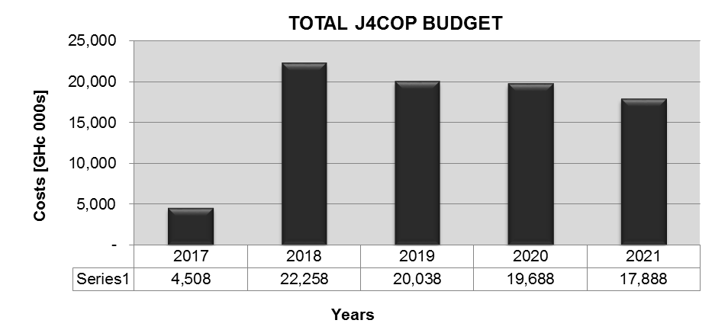



**Figure 1: Total J4COP budget for the 5-year period 2017-2021**

**Notes:**

1. The cost estimates in this J4COP are current costs of March 2017.
2. These costs are in addition to the normal budgets of stakeholders for salaries and day to day operations. This J4COP budget includes all required strategic initiatives required to achieve the seven policy objectives. These strategic initiatives (programmes, projects and activities) include capital as well as non-capital initiatives.
3. These are just cost estimates and will have to be verified in future. When detailed project plans are developed, based on status quo assessments, more accurate costs can be determined.
4. The scorecards will be updated on a quarterly basis as more information become available. Refer to Annexure C: Implementation Guidelines.
5. The specific funding sources for the various strategic initiatives are to be determined. Obtained funds for this OP will be managed according to the approved funding mechanism by the NCPC/J4CCC supported by the DOC secretariat.

***Figure 2*** depicts the distribution of costs among the seven policy objectives. It will be noted that Objective 2, the promotion / capacity building of the formal and community justice systems, require the majority of funds, namely 70%.

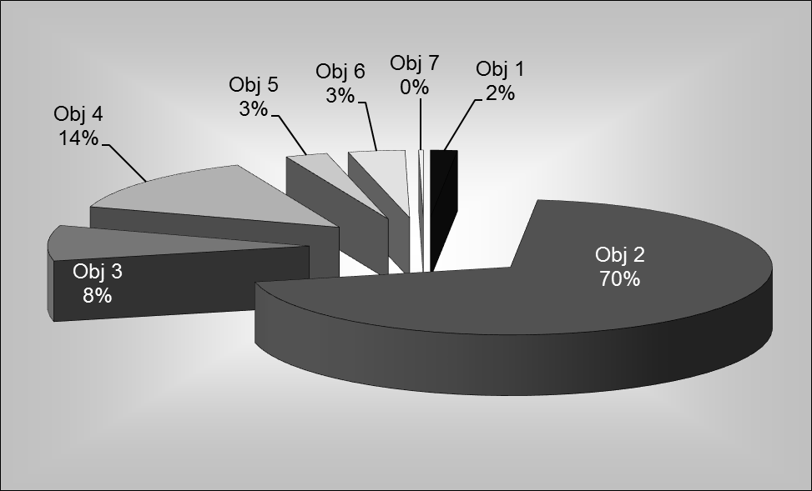

**Figure 2: Cost** **distribution among the seven objectives**

# ANNEXURE A: J4C STAKEHOLDERS

The Justice for Children Stakeholder Map is presentedbelow depicting key stakeholders in relation to one another on national, regional, district and community levels. On the right-hand side, the various Child Protection Committees (CPCs) are shown.

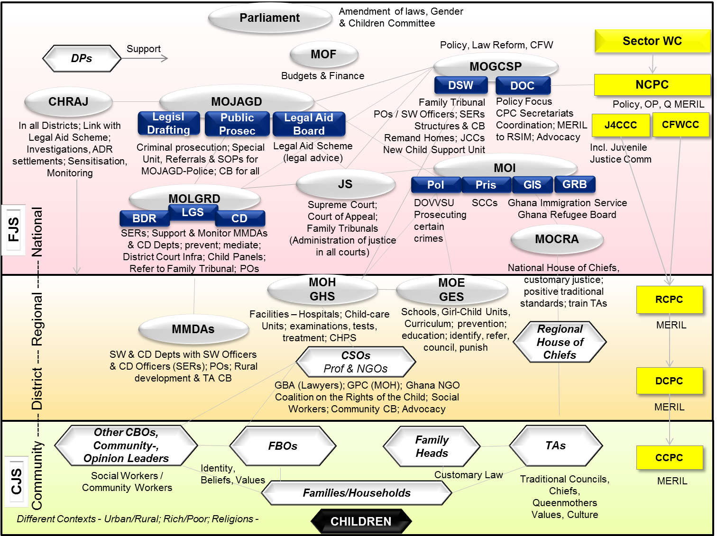

# ANNEXURE B: J4C PROCESSES

|  |  |
| --- | --- |
| The CJS within the broader FJS is depicted in ***Figure B1***showing the Child (C) in the centre, surrounded by the Family (F) and then the FBOs / CBOs / NGOs, operating in the Child’s immediate environment, forming part of the Community Justice System (CJS). The outer box represents the Formal Justice System (FJS). The legal process for offenders are shown from the centre towards the bottom right with the rehabilitation, reconciliation and reintegration process indicated by the broken line arrows from the top right back to the community/family/child. | **Figure B1: Community & Formal Justice Systems** |

The civil and criminal processes, through the CJS and FJS are briefly described below. Note that initiatives in this J4COP address the development of Standard Operating Procedures (SOPs), supported by manuals.

## CIVIL PROCESS

When there are civil problems relating to a child (non-maintenance, custody, parentage, estate, care order etc.) the matter will initially be handled under the CJS with the use of Alternative Dispute Resolution (ADR) mechanisms by the actors at that level. Such problems could be reported by a custodial parent or by a school. Family conferences could be held and if necessary community conferences held as well. The CCPC will be responsible for monitoring and recording such settlements. If the outcome is accepted it is settled at that level and if not depending on the nature of the matter it could be taken to the Child Panels at the District level or reported to the FJS through the DSW or the Police.

Within the FJS non-maintenance is both a criminal and civil matter so the Police may take the matter to the criminal court for the perpetrator to be tried and sentenced. If it is also an estate matter in which properties a child is entitled to have been taken away or the child has been ejected from parental property the Police can also come in to deal with the criminal aspect of the matter. The Police have the right to call in the DSW to undertake SER to guide in how to process the matter further or to divert it.

Most cases relating to children are however referred to the DSW who initially try to mediate or to a lawyer (that may be on legal aid basis) to take to the court. If it is not possible they refer it to the Family Tribunal if it is a matter relating to non-maintenance, custody, denial of parentage or application for a care order. If it is an estate matter relating to parental property the matter depending on the value of the property, can be referred to the District Court, Circuit Court or High Court. Whilst at the court the DSW will be required to prepare a SER. The court has the right to refer the case back to the CJS for settlement and reporting of outcome to them. Final orders or judgments are made depending on the nature of the matter and they have to be implemented or enforced by various means.

If the matter is about a care or supervision order, rehabilitation, resettlement or reintegration could be ordered and the process supervised by a probation officer. Some orders will require the payment of maintenance or the confirmation or change of custody arrangements for a child. Orders relating to estate matters will require restitution or properties a child is entitled to be given to them or orders made to put them back into properties of parents they have been ejected from.

Whatever the nature of the order is Probation officers will if ordered by the court make home visits or visits to schools to see the progress of implementation.

With regard to cases relating to non-maintenance, the Children’s Act will be amended to set up a Child Support Unit (CSU). This CSU will take the responsibility to pursue parents who have to contribute to the maintenance of their children, collect their contribution and the custodial parent will pick up the money from their office.

The Civil process (including non-maintenance, custody, paternity and neglect cases) is shown in ***Figure B2.***

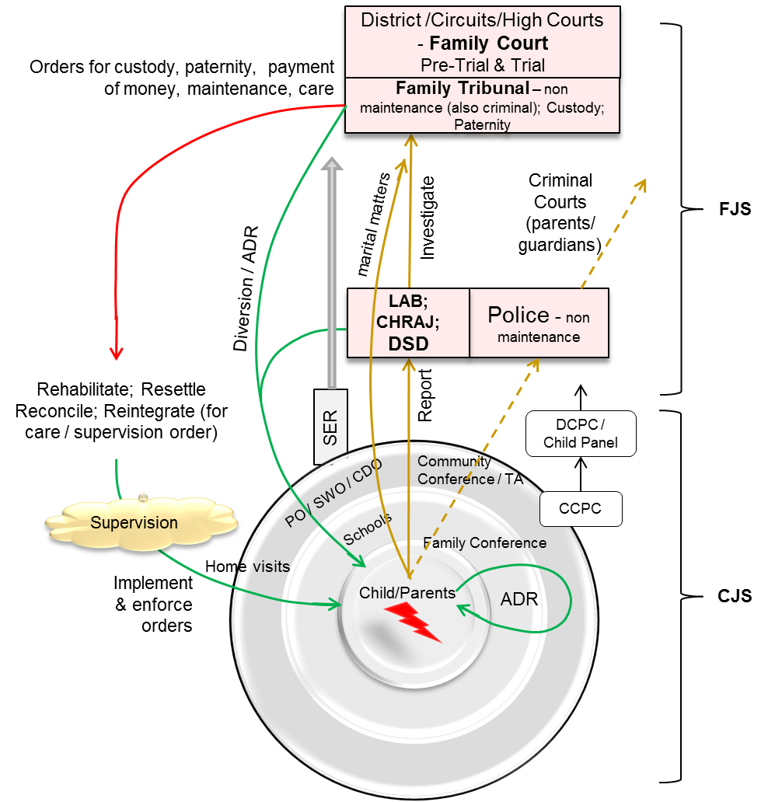

**Figure B2: Civil Process**

## CRIMINAL PROCESS

When a child is a perpetrator in a minor criminal offence within the community or in school the Juvenile Justice Act allows such matters to be settled by the CJS/Child Panels using ADR. The settlement can be done through family conferences or community conferences with the support of the CCPC. If the matter can be settled at the community level, the child can be made to make amends, compensate the victim, advised to make better decisions, rehabilitation, restitution etc.

If the matter cannot be settled at the community level or it is a serious offence then it has to be reported to the Police/DOVVSU. Once it involves a child the DSW will be called in to help the child and assist with the investigations. The Police have the right to arrest perpetrators and if they are children to take them to court to be remanded in the JCC once their age is confirmed or to divert them to the CJS where possible. They will undertake their investigations and prosecute at the Juvenile Court which is at the District Court level. The court has the power to order a SER and also to divert them to the CJS for ADR to be used to settle the matter and the outcome reported.

If there is no diversion after the trial they may be committed to the JCC (if aged between 12 and 17 years) or the SCC (if aged between17 and 21) or depending on the seriousness of the offence committed for a maximum of 3 years. Whilst on committal they will be counseled and rehabilitated. They may also be given a non-custodial sentence and undertake to be of good behavior under probation for a specified period. They will go back to the community level and the CJS can help to supervise and ensure their rehabilitation etc. under the supervision of Probation officer.

The process describing criminal cases is depicted in ***Figure B3***.

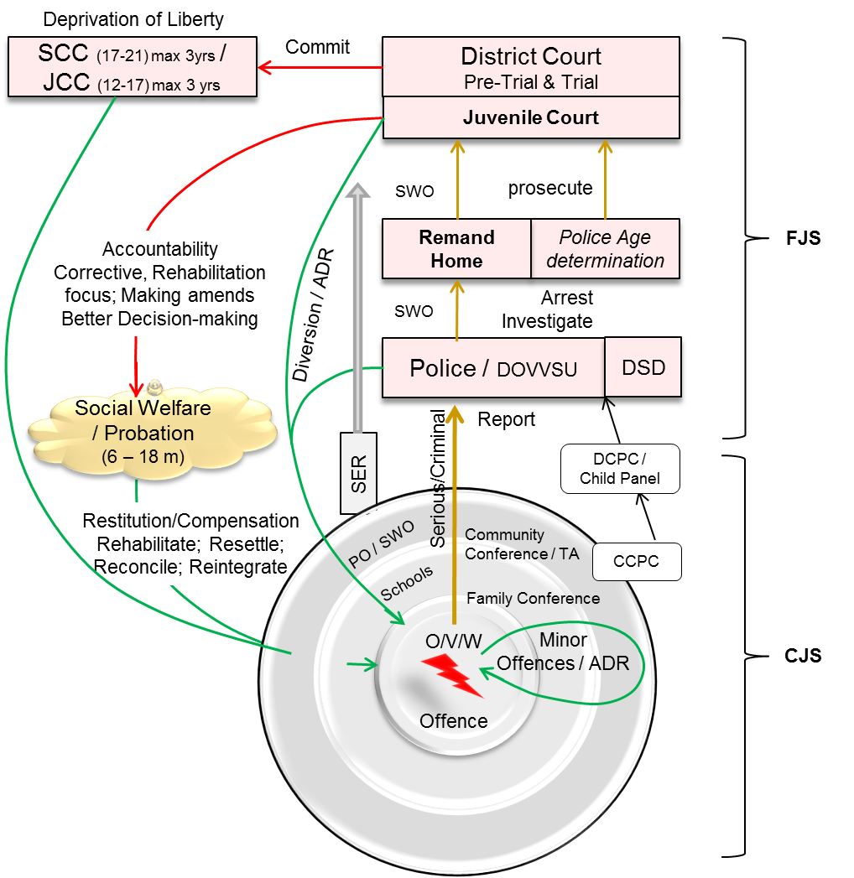

**Figure B3: Criminal Process (for offenders)**